**Lesson09 Azure App Service Deployment Slots**

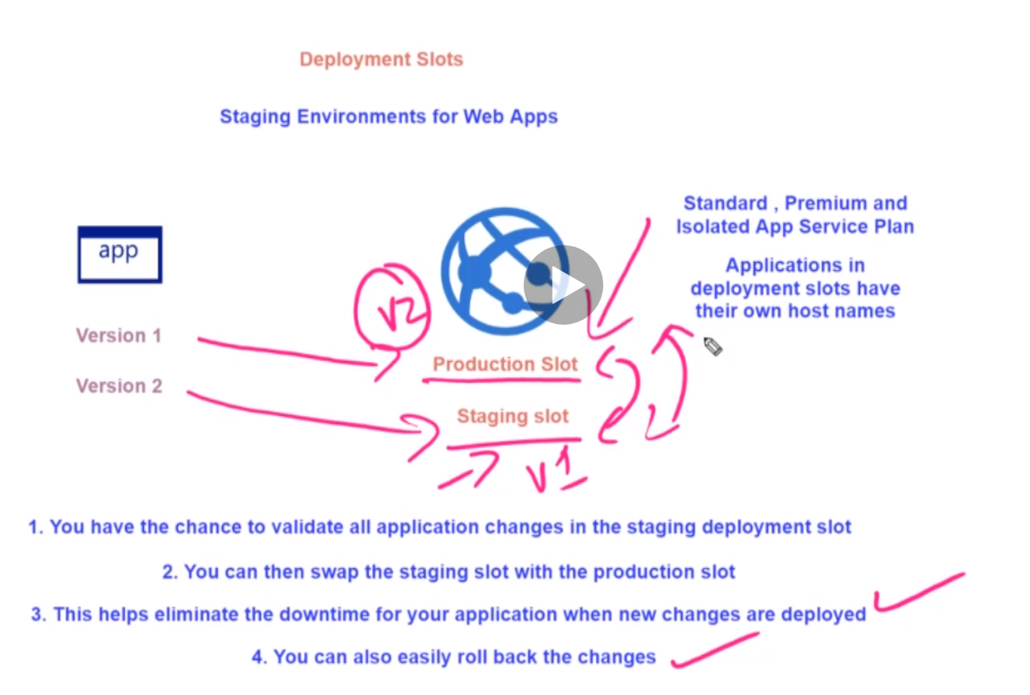

**1-With using Azure Deployment Slots, you can make 2 versions web app and the version 01 will assigned to production slot and version 02 will assigned into staging slots**

**2-The benefits of using Deployment Slots when the QA version accepted you can swap with the production, so the version 02 is assigned as production slot while version 01 assigned as staging slot**

**3-it eliminate the downtime of prepare new changes on the Azure app service and set each slot to its specific configuration and swap between them and each one read from its configuration**

**4-each slot has its own DNS name**

**Deployment Slots in Labs**

**Notes: -**

**1-create app service with .net core deployment**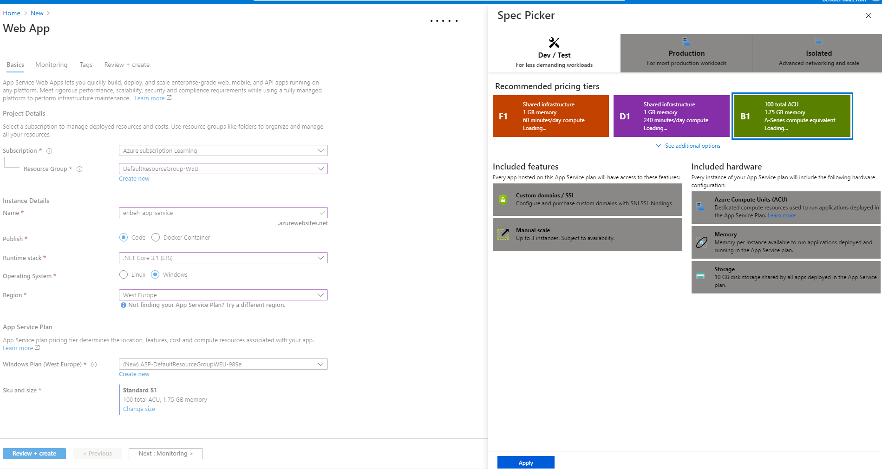

**2-we make .net core app and publish it to azure web app**

**(In order to apply deployment slots on the app services, make sure that you have standard of premium app service plan – production mode)**

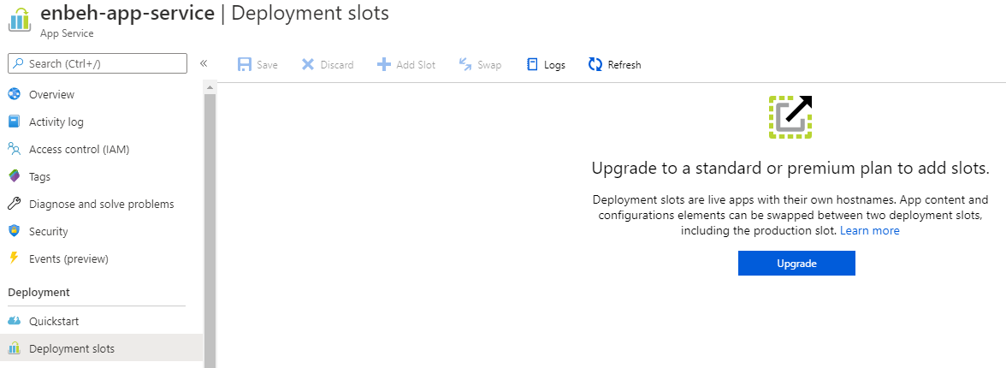

**3-so we must scale up the app service to standard mode > on production stage as below > azure portal > app service > scale up**

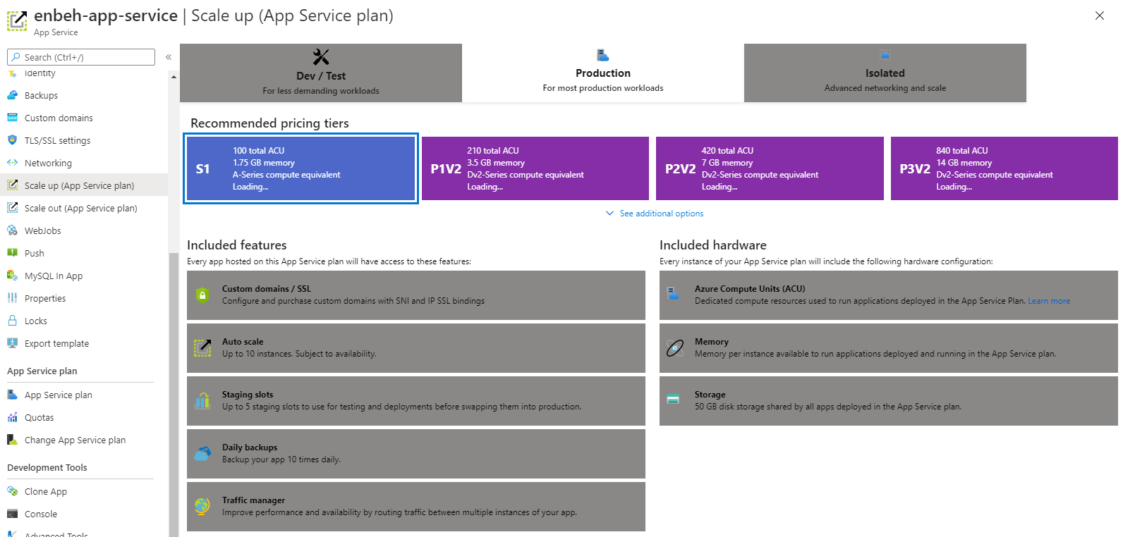

**4-you see now that the deployment slots is opened and you see that there are main deployment slot with 100% traffic which means that all users will hit to this deployment slot**

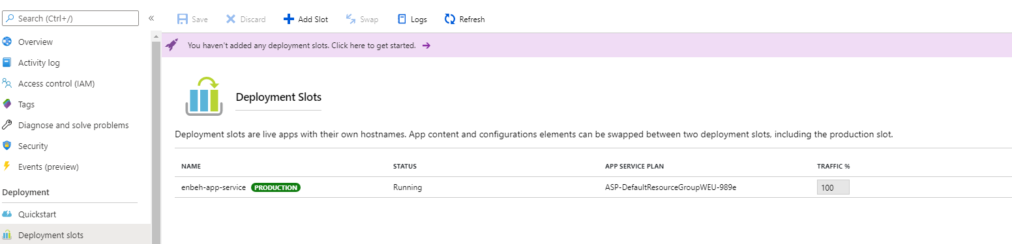

**5-create new deployment slot and name it as Enbeh-app-service-v2**

**🡪 do not clone settings**

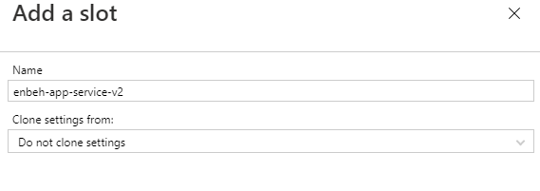

**6-on VS 2019 make publish on the project and select the Enbeh-app-service-v2 deployment slot and make publish**

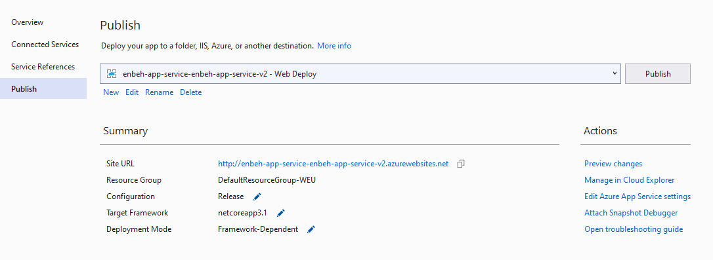

**7-we see that each deployment slot has its DNS name and different versions**

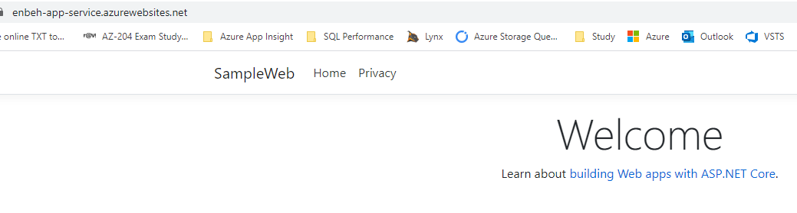

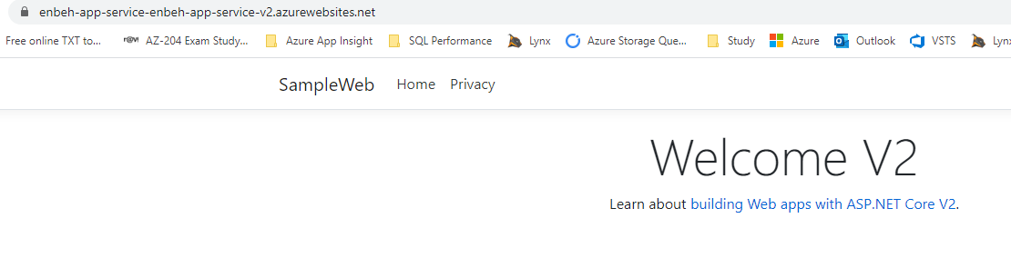

**8-in order to swap between deployment slots to swap between deployment slots**

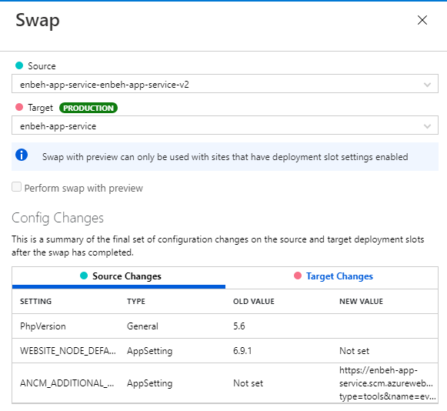

**9-you see finally that the DNS reflected with the source project versoin**

**10-we see that it will create new Deployment slot as resource separated that inherit from the app service that use the same service plan**

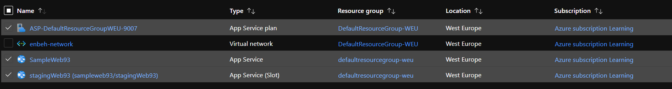

**Lesson14 Deployment Slots in Labs Using Azure PowerShell**

**Notes: -**

**// First you can go ahead and create variables that can be used in the PowerShell script. Here we are setting the location for the web application, the name of a new resource group and the name of the new Azure Web App**

**$location="Central US"**

**$resourcegrp="newgrp"**

**$webappname="demoapp4040"**

**// Next, we issue the command to create a new resource group**

**New-AzResourceGroup -Name $resourcegrp -Location $location**

**// Next, we issue the command to create a new App Service Plan**

**New-AzAppServicePlan -Name $webappname -Location $location -ResourceGroupName $resourcegrp -Tier Standard**

**// Next, we issue the command to create a new Web App with App Service Plan**

**New-AzWebApp -Name $webappname -Location $location -ResourceGroupName $resourcegrp -AppServicePlan $webappname**

**// Next, we issue the command to create a new Web App deployment slot**

**New-AzWebAppSlot -Name $webappname -ResourceGroupName $resourcegrp -Slot "staging"**

**//we see that we create new deployment slot on azure app service**

